**DISSERTATION**

“**EATABLES**”

SUBMITTED IN PARTIAL FULFILLMENT OF THE REQUIREMENTS FOR THE AWARD OF

THE DEGREE OF

**BACHELOR OF COMPUTER APPLICATION (BCA)**

**AT**

**DEPARTMENT OF COMPUTER SCIENCE, APPLICATION & ANIMATION**



**ST ALOYSIUS COLLEGE (AUTONOMOUS), MANGALURU**

**MR DARSHAN DINESH M.P – 204683**

WORK CARRIED OUT AT

**ST ALOYSIUS COLLEGE (AUTONOMOUS), MANGALURU**

DURING THE ACADEMIC YEAR 2022 – 23

UNDER THE GUIDANCE OF

|  |  |  |  |
| --- | --- | --- | --- |
| **INTERNAL GUIDE** |  |  | **EXTERNAL GUIDE** |
| **Ms Vidya Kumari**  Assistant Professor, Department of BCA  St Aloysius College (Autonomous)  Mangaluru – 575 003 |  |  | **Mr Royal Praveen Dzousa**  Assistant Professor, Department of BCA  St Aloysius College (Autonomous)  Mangaluru – 575 003 |

# MAY, 2023

**DISSERTATION**

“**EATABLES**”

SUBMITTED IN PARTIAL FULFILLMENT OF THE REQUIREMENTS FOR THE AWARD OF

THE DEGREE OF

**BACHELOR OF COMPUTER APPLICATION (BCA)**

**AT**

**DEPARTMENT OF COMPUTER SCIENCE, APPLICATION & ANIMATION**



**ST ALOYSIUS COLLEGE (AUTONOMOUS), MANGALURU**

**MR DARSHAN DINESH M.P – 204683**

WORK CARRIED OUT AT

**ST ALOYSIUS COLLEGE (AUTONOMOUS), MANGALURU**

DURING THE ACADEMIC YEAR 2022 – 23

UNDER THE GUIDANCE OF

|  |  |  |  |
| --- | --- | --- | --- |
| **INTERNAL GUIDE** |  |  | **EXTERNAL GUIDE** |
| **Ms Vidya Kumari**  Assistant Professor, Department of BCA  St Aloysius College (Autonomous)  Mangaluru – 575 003 |  |  | **Mr Royal Praveen Dzousa**  Assistant Professor, Department of BCA  St Aloysius College (Autonomous)  Mangaluru – 575 003 |

# MAY, 2023

|  |
| --- |
| **ST ALOYSIUS COLLEGE (AUTONOMOUS), MANGALURU** |
|  |
| **Department of Computer Science, Application & Animation** |

# CERTIFICATE FOR THE APPROVAL OF THE PROJECT

This is to certify that **MR DARSHAN DINESH M.P** bearing the Register number **204683** of VI Semester BCA have satisfactorily completed the project “**EATABLES**” for the **Bachelor of Computer Application (BCA)** prescribed by the College during the academic year 2022 – 23.

|  |  |  |
| --- | --- | --- |
| **PROJECT GUIDE SIGNATURE** |  | **HOD’S SIGNATURE** |
| **Ms Vidya Kumari**  Assistant Professor, Department of BCA  St Aloysius College (Autonomous)  Mangaluru – 575 003 |  | **Ms Shilpa Shetty**  HOD, Department of BCA  St Aloysius College (Autonomous)  Mangaluru – 575 003 |
|  |  |  |
|  |  |  |
|  |  | **Examiners:** |
| **PRINCIPAL SIGNATURE** |  | **1.** |
| **Rev. Dr Praveen Martis, SJ**  Principal  St Aloysius College (Autonomous)  Mangaluru – 575 003 |  | **2.** |

**DECLARATION BY STUDENT**

We hereby declare that this project work titled “**EATABLES**” has been prepared by us during the academic year 2022 – 23 under the guidance of **Ms Vidya Kumari**

, Assistant Professor, Department of Computer Science, Application & Animation, St Aloysius College (Autonomous), Mangaluru submitted in partial fulfillment of the requirements for the award of the degree of **Bachelor of Computer Application (BCA)** as prescribed by the College.

We also declare that this project is the outcome of our efforts, that it has not been submitted to any other University for the award of any degree or diploma.

**MR DARSHAN DINESH M.P – 204683 SIGNATURE**

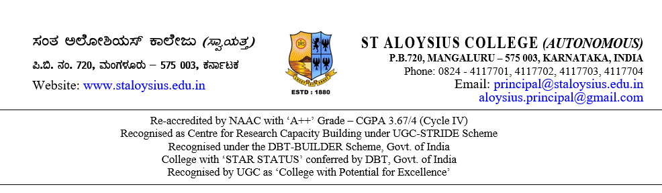

**TO WHOMSOEVER IT MAY CONCERN**

This is to certify that Mr / Ms ____________________________________________ bearing Reg. No. __________________ studying in VI Semester BCA, of our College during the academic year 2022–23 has done his / her project on the topic titled “___________________________________________________” for the purpose of partial requirements for the award of the degree of Bachelor of Computer Application (BCA).

He / She has collected information from us and has satisfactorily completed the project under our guidance during the period from January 2023 to May 2023. During this tenure, his / her conduct and character was found good.

Thanking You,

Yours truly

(Name & Signature)

Place:

Date:

**ACKNOWLEDGEMENT**

Our team's dedicated efforts have allowed us to successfully complete this project. However, we recognize that this achievement would not have been possible without the generous support and assistance of numerous individuals. It is with deep appreciation that we acknowledge their contributions, as they played a vital role in our success. We are honored to mention and thank them for their invaluable help throughout the project.

We have taken this opportunity to thank **Rev. Dr Praveen Martis, SJ** Principal, St. Aloysius College (Autonomous), Mangaluru for all the blessings and good wishes, which supported us in our endeavour.

Special thanks to **Dr Ravindra Swami K**, Dean **and Ms Shilpa Shetty**, HOD of Department of Computer Application, for supporting us and being the source of inspiration of the course.

We also thank our internal guide **Ms Vidya Kumari** and external guide **Mr Royal Praveen Dzousa** for his through reviews and guidance through the various stages of the project.

We would also like to thank all the lectures of the Computer Science Department for their guidance and constant encouragement which helped us in successfully completing the project. Our whole hearted thanks to our parents who have supported us in all aspects of this project. We would also like to thank all the people, directly and indirectly involved in this project, without whose help the completion of this project would have been virtually impossible.

**MR DARSHAN DINESH M.P – 204683 SIGNATURE**